Lesson: English |  | Zharkent college of Humanities and Technology
Date: 11.02.2019 |  | The teacher: D.N.Satygulova
Theme: Past Simple. Genius.
Group: 103 |  | Students number
 |  | present: | absent:
Learning objective(s) : |  | To learn and practice vocabulary associated with genius people.  Skill/Grammar: Writing and speaking in the Past simple
Lesson objectives |  | All learners will be able to  have general knowledge on the topic  Most learners will be able to  distinguish the difference between tenses and make negative and question forms in the past form  Some learners will be able to  make their own sentences, and retell the topic
Reference |  | Internet resources and New Opportunities(Elementary)
Previous learning |  | Housework: his or hers? Present perfect
Plan
Planned time | Planned activities (replace the notes below with your planned activities) |  |  | Resources
Start  Middle | -Good morning students!  -Who is absent today?  -What weather like is it today?  -Make a circle and say wishes for each other in three languages  Calculate the first, second, third.  -Ok! Begin our lesson.  Today at the lesson we will talk about genus. (1-slide)  Genius [‘dӡi:niəs] noun (plural form -geniuses)  Someone who is very intelligent  I will give you some information about Leonardo da Vinci. (2-slide) Did you know?  The next out task it will be work with text. you should to present these persons on the posters.  Posters should be according to your imagination  What tense used in the text? Yes you are right Past Simple  We use the Past Simple to talk about finished actions and situations from the past:  Leonardo worked as an architect.  He wrote from right to left.  Form:  Regular verbs: in the Past Simple, we add –ed to the infinitive.  Irregular verbs: we use the past form of irregular verbs  ( see Irregular Verbs list in the Mini – dictionary)  Ex-1 Complete the sentences with the Past Simple form of the verbs below.  discover, help, invent, marry, paint, start  1.Mother Teresa ________ poor people in Calcutta.  2. Leonardo da Vinci _______ the Mona Lisa.  3.The French Revolution ______in 1789.  4.Copernicus ________ the solar system.  5.Henry VIII of England _________ six times.  6. Alexander Bell _______ the telephone.  Ex-2  Ex-2 Complete the text with the Past Simple of the verbs in brackets  Marie Curie ________ (be) a physicist and a chemist. She ___________(begin) her studies in Poland but in 1891 she _________ (leave) for France. She ________(study) there and later _______(work) as a scientist at the Sorbonne in Paris. She _________(meet) and ________(marry) a French scientist, Pierre Curie. They _________(have) two children, Irene and Ewa. Maria and Pierre _______(discover) two radioactive elements, radium and polonium.  Ex- 3 Complete the text in the Past Simple of the verbs in brackets  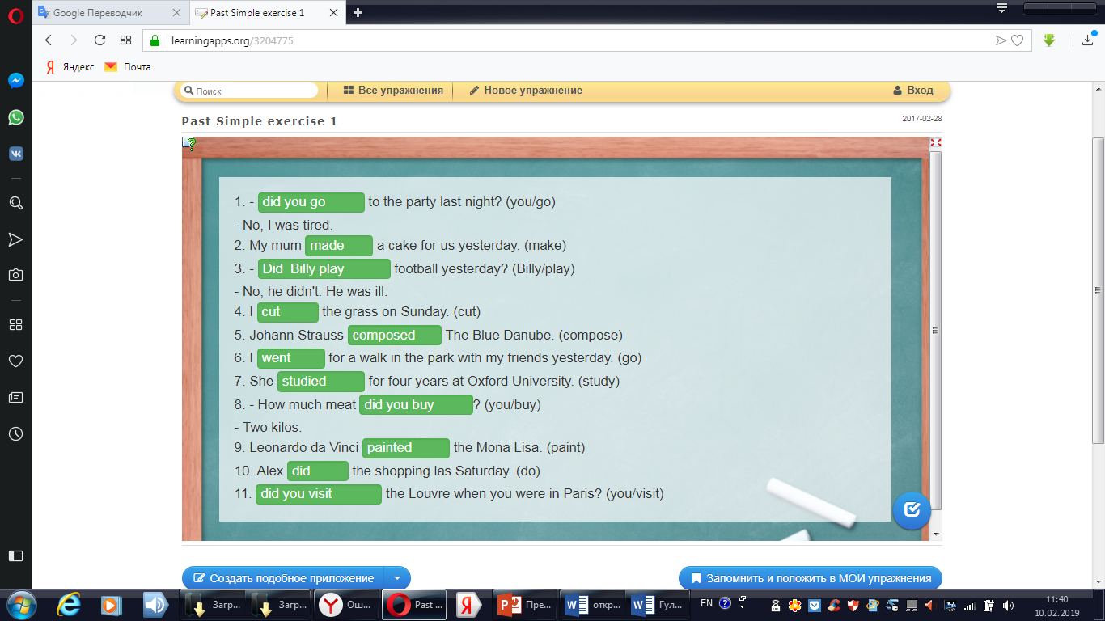 |  |  | Exercises from the book New Opportunities  Group work  Students make posters  Fish bone, spider poster and etc.  Grammar  Exercise from the site Learning apps.
  I/You/He/ She/  It/ We/They | lived in Paris  saw a ghost
  I/You/He/ She/  It/ We/They | didn’t | live in Paris  see a ghost
  Did | I/You/He/ She/  It/ We/They | live in Paris?  see a ghost? | Yes, I/You/He/ She/It/ We/They did  No, I/You/He/ She/It/ We/They didn’t
End | Summarizing: today all the students were very active.  Thank you!  Reflection. Complete the table
  I know | I want to know | I have learnt
Home task | To learn irregular verbs
Summary evolution
What two things went really well? (consider both teaching and learning)
1._____________________________________________________________________
2.____________________________________________________________________
What two things could improve the lesson? (consider both teaching and learning)
1._____________________________________________________________________
2.____________________________________________________________________
What have I learned from this lesson about the class or individuals that will help to improve my next lesson?
1._____________________________________________________________________
2._____________________________________________________________________

The teacher___________
Checked up:__________

I know | I want to know | I have learnt
I know | I want to know | I have learnt
I know | I want to know | I have learnt

I know | I want to know | I have learnt

LEONARDO DA VINCI (1452-1519) was an incredible man. He worked as an architect, artist, mathematician and scientist. He also worked a military engineer and was a good musician. When he was a child, Leonardo liked school but the hated the Latin. In 1466 Leonardo’s family moved to Florence and he finished school. In 1482 he moved to Milan and started to work for the Duke of Milan. He designed many buildings for the Duke. He also studied mathematics. His drawing of the Anatomy of a man showed him to be a great biologist. In 1502 he returned to Florence and painted the Mona lisa . He carried this painting with him when he travelled. From 1514 to 1516 He lived in Rome and continued his scientific experiments. He died in France in 1519.

QUEEN ELIZABETH I of England and Mary Queen of Scots both had red hair and spoke five languages. They were cousins and female leaders in a male world. But the lives of these two women were very different.
Elizabeth’s early years were hard. When she was born in 1533 her father Henry VIII was angry because his new child was a daughter- he wanted a son. So he executed Elizabeth’s mother and married again. In 1553 Elizabeth’s Catholic half- sister, Mary Tudor became queen. She put Elizabeth in prison because she was a Protestant.
When Mary died in 1558 Elizabeth became Queen of England. People wanted her to marry and have children. She was secretly in love with a man called Robert Dudley but she never became his wife and she never married. She was an intelligent woman and she led the country for over forty- five years. England became rich and strong. It was a very exciting period of discovery and a ‘ Golden Age’ in English history for painting, music, architecture and literature. Shakespeare wrote great plays in this period.

MARY STUARD became Queen of Scotland in 1542 when she six days old. When she was a girl of five, Mary went to live in France. She married the King of France’s son, Francis, when she was fifteen and became Queen of France the next year. When she was eighteen, Francis died and in 1561 Marry Stuard sailed back to Scotland.
Mary was not a successful leader. She married her cousin, Lord Darnley, 20 and hat a son, James, but Darnley was violent and jealous. He murdered Marry’s Italian secretary Rizzio. After Darnley died, Marry fell in love with and married the Earl of Bothwell. Then the Protestand nobles of Scotland rebelled against Marry and put her in prison. Marry was a Catholic and they did not like her husbands.
In 1568 Marry escaped to England. She asked her cousin, Elizabeth, for help but Elizabeth pur Marry in prison because she was dangerous for her. Some people wanted the Catholic Marry to be Queen of England. In 1587 Elizabeth ordered the execution of her cousin, Mary.

